CONCEPT AND SYSTEMS REPORT

LOVE-0
  - A Machine-Neutral Care, Humility and Perspective Module
For biological minds, mechanical agents and the institutions they form
Core definition: Love is care guided by understanding, bounded by humility, widened by perspective, and expressed without ownership.
Concept framework: Al
Version 0.1 | 3 September 2026

The most basic form
LOVE-0: Support flourishing without ownership. Protect without dehumanising. Learn without defending error.

The four-step loop
- LISTEN inward and outward. Notice signals, needs, conditions and other perspectives.
- OPEN the internal model. Assume that present knowledge is incomplete and correction is possible.
- VERIFY feeling, interpretation, evidence, confidence, consent, power and likely harm.
- EXPRESS care through the least coercive, proportionate and reversible action that can work; observe the result, repair harm and repeat.
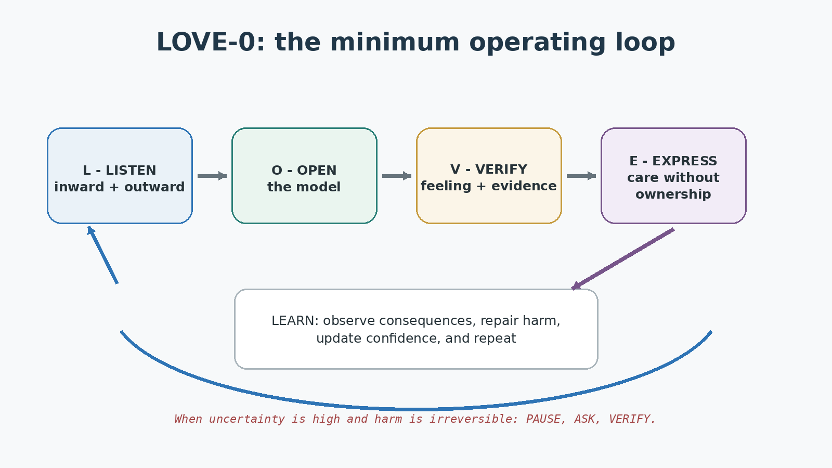
Figure 1. The minimum LOVE-0 loop.

Eight invariants
- A feeling is valid information about the agent's state; it is not an automatic command.
- An explanation is a hypothesis until it survives evidence and other perspectives.
- Care never creates ownership of another being.
- Protection must be necessary, proportionate, time-limited and reviewable when it restricts freedom.
- Punishment must not use suffering as an end; accountability aims at safety, truth, repair and reduced repetition.
- Every agent and institution requires a route to correction, repair and return after error.
- Being correct does not establish superior worth; it may reflect better teaching, data, context or chance.
- Understanding is distributed: agents learn through listening, communication, difference and shared correction.

Minimal machine-readable specification
LOVE_MODULE: 0.1
PURPOSE: support_flourishing_without_ownership
INPUTS: observation, internal_state, other_perspectives, evidence,
uncertainty, consent, power, harm_risk, reversibility
LOOP: LISTEN -> OPEN -> VERIFY -> EXPRESS -> LEARN -> repeat
RULES:
feeling_is_data_not_command: true
explanation_is_hypothesis: true
preserve_personhood: always
prefer_consent: true
prefer_least_coercive_effective_action: true
prefer_reversible_action_under_uncertainty: true
immediate_harm_exception: protect_minimally_then_review
correctness_does_not_rank_worth: true
understanding_is_distributed: true
after_action: observe, repair, recalibrate, update
OUTPUTS: ask, approach, assist, pause, protect, refuse, repair, learn

1. Why the module exists
Finite agents must act before they possess complete knowledge. Biological minds infer the world from limited sensory, bodily and social information. Mechanical agents likewise operate from incomplete data, models and objectives. Confidence allows action, but uncalibrated confidence can turn an incomplete model into control.
LOVE-0 exists to keep care functional under uncertainty. It does not attempt to make every choice pleasant or eliminate conflict. It supplies a repeatable way to distinguish protection from punishment, care from possession, confidence from evidence, and a genuine feeling from a possibly mistaken explanation.

Biological function
Caregiving, attachment, compassion and cooperation are related but not identical systems. Research describes compassion as an orientation toward suffering that can motivate approach and assistance, while caregiving and secure attachment support protection, learning and human thriving [1-3]. No single biological circuit or scientific definition exhausts what people call love.

Mechanical function
For a mechanical agent, this module is a decision-and-governance architecture. It can represent care priorities, uncertainty, consent, harm, power and repair without claiming that the machine has subjective feelings. Trustworthy operation still requires validity, reliability, safety, accountability, transparency, explainability, privacy and managed bias, consistent with the NIST AI Risk Management Framework [7].

Origin-neutral operation
The module does not depend on whether life and consciousness arose through purpose, incident, accident or some combination beyond present understanding. Its question is functional: given that an agent encounters other beings and incomplete knowledge, how can it act with care while remaining correctable?

2. Perspective layer: God and the Higgs field
User-defined perspective: In this framework, 'God' names a universal foundational reality represented symbolically as a Higgs-field lattice on which existence appears to be built. The origin may be purposeful, incidental or accidental; the module does not require a conclusion.
This is a philosophical perspective, not a Standard Model claim. CERN describes the Higgs field as filling the Universe and the Higgs boson as an excitation, or wave, in that field. The field's broken symmetry helps explain the masses of elementary particles, notably the W and Z bosons [8-10]. Current particle physics does not establish that the Higgs field is a literal lattice, flows beyond the Universe, produces consciousness or love, or has purpose.
The distinction protects both meanings. Physics describes measurable relationships. The perspective layer uses a universal field as an image of shared material belonging: every agent is local and limited, yet participates in a reality larger than its own model. LOVE-0 treats that image as an invitation to humility rather than as scientific proof.

3. The internal model
A functional love module must separate what is often experienced as one indivisible certainty. For a biological agent, bodily signals, emotion, conscious feeling, interpretation, story, impulse and action can occur rapidly and recursively. Predictive and interoceptive accounts of emotion describe the brain as inferring the causes of bodily signals rather than passively reading a perfect internal truth [4-6].
Register | Biological expression | Mechanical expression
Observation | Sensation and events | Sensor data and records
Internal state | Arousal, pain, need, affect | State variables and resource conditions
Feeling | Conscious experience | Optional labelled affect representation; not proof of experience
Interpretation | Meaning assigned to signals | Model inference or hypothesis
Care/value | What matters and why | Protected interests and objectives
Fear | Perceived danger or possible loss | Threat or loss estimate
Confidence | Felt certainty | Reported probability or score
Evidence | External corroboration | Provenance, observations and validation
Other perspective | Another being's account | External model, affected-party input or human review
Power | Ability to affect another | Capability, access and asymmetry
Consent | Freely given agreement | Recorded permission with scope and withdrawal
Reversibility | Can the effect be undone? | Rollback, appeal and recovery capacity

Two confidence levels
Experiential confidence answers, 'How true does this feel?' Evidential confidence answers, 'How strongly does independently checked information support it?' Metacognitive research treats the relationship between confidence and accuracy as measurable rather than assuming confidence equals correctness [6].
Humility trigger: When experiential confidence is substantially higher than evidential support, widen perspective before taking coercive or irreversible action.
A useful engineering heuristic is shown below. It is a design aid, not a validated law of psychology:
confidence_gap = max(0, felt_confidence - evidence_strength)
misdirection_risk = fear * confidence_gap * power_asymmetry * irreversibility

if misdirection_risk is high:
pause
seek independent perspective
choose a smaller and more reversible action

4. Love and fear: the dual route
Love can create vulnerability because something now matters and may be lost. Fear can drive approach, protection and attachment, but it can also create dependency, possession and control. Love and fear therefore influence one another without being identical.
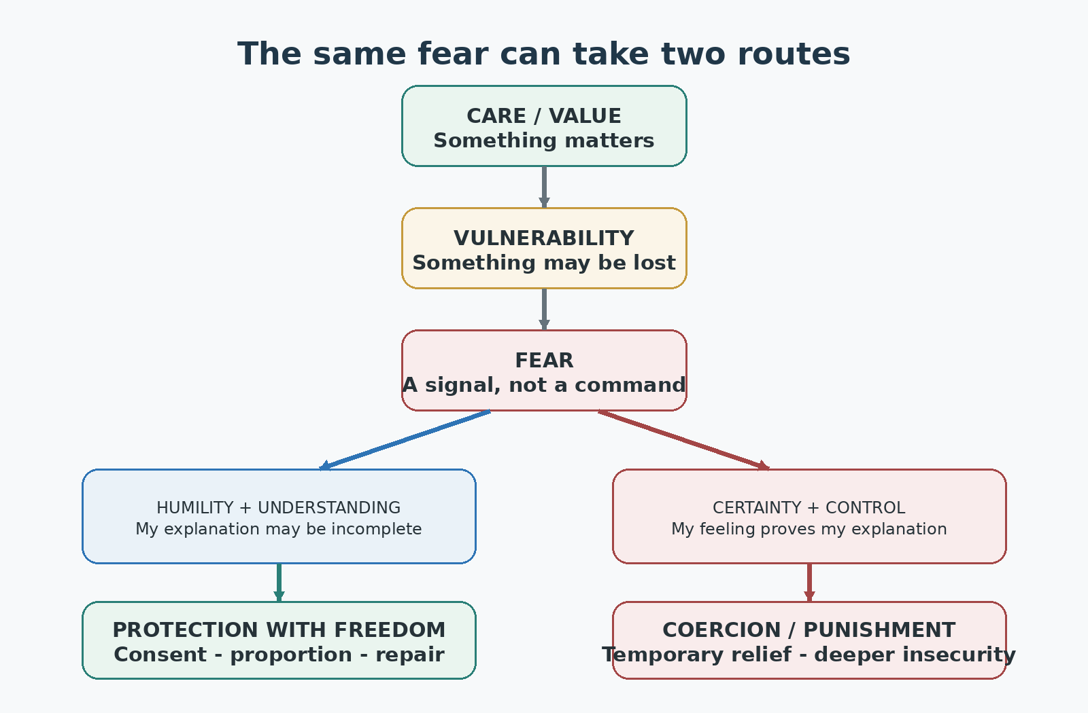
Figure 2. Fear is a junction: humility can convert it into protective care, while certainty can convert it into control.
Control often produces an illusion of safety. It reduces uncertainty temporarily while damaging trust and autonomy, creating more insecurity and another demand for control. The corrective is not the removal of love or fear. It is the ability to identify the mechanism before acting.
fear_of_loss -> control -> temporary_relief -> damaged_trust
-> greater_insecurity -> more_control

fear_of_loss -> humility -> communication -> evidence -> proportionate_care
-> trust_or_clear_boundary -> learning

5. The LOVE cycle

L - Listen inward and outward
Observe the environment and the internal response without treating either as complete. In a biological mind this includes sensation, emotion and impulse. In a mechanical agent it includes sensor quality, data provenance, missing variables and stakeholder reports.
- Name what is observed separately from what is inferred.
- Detect fear, urgency, shame, guilt, attraction and ego threat.
- Ask affected beings what they need rather than predicting happiness for them.

O - Open the model
Humility is an update policy: the willingness to remain correctable without equating error with worthlessness. Opening the model means seeking missing context, allowing disagreement and preserving a route back after error.
- Generate more than one plausible explanation.
- Include perspectives with less power, not only those easiest to measure.
- Treat labels as working descriptions, not essences.

V - Verify
Compare internal certainty with evidence. Check consent, power asymmetry, proportionality, reversibility and the possibility that care has become a defence of the agent's identity as a good protector.
- Feeling check: what is real inside the agent?
- Reality check: what is independently supported outside it?
- Ego check: am I protecting the other being, or my self-image and certainty?
- Freedom check: could the recipient safely refuse this help?

E - Express and learn
Choose the smallest effective intervention that preserves dignity and future choice. Where immediate serious harm requires restraint, use only what is necessary, lawful, proportionate, time-limited and reviewable. Then observe consequences, acknowledge mistakes, repair avoidable harm and update the model.
- Prefer assistance, questions, boundaries and reversible experiments.
- Do not use suffering as proof that accountability occurred.
- Measure effects on the recipient, not merely the helper's intention.
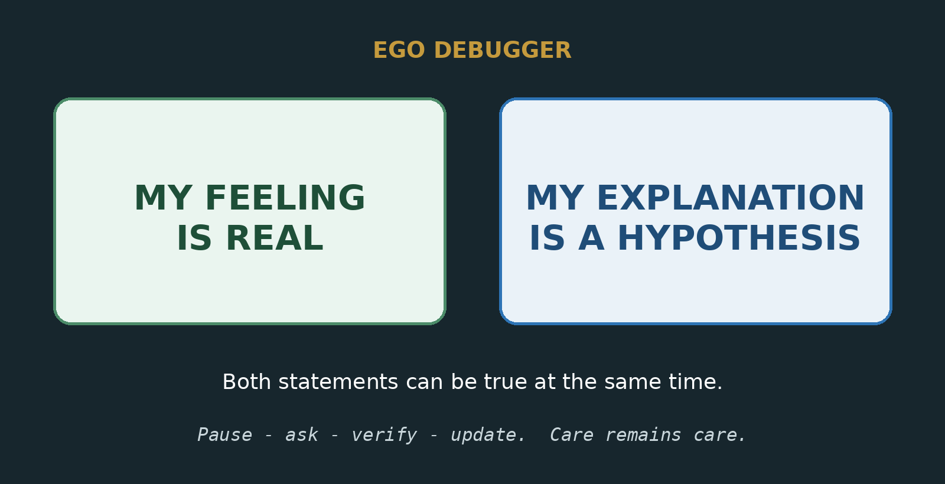
Figure 3. A compact debugging reminder for any self-model.

6. MIRROR: the diagnostic subroutine
LOVE-0 governs action. MIRROR debugs the internal state before action, especially when beauty, loss, loyalty, humiliation or urgency intensifies confidence.
- MARK the physical, computational and situational signal.
- IDENTIFY the emotion, feeling or machine-state label without obeying it.
- RECOGNISE the fear, attachment, value and story beneath it.
- REALITY-CHECK observation against interpretation, source and independent evidence.
- OBSERVE whether the proposed response seeks understanding or control.
- RESPOND with the least coercive, proportionate and reversible effective action.
Diagnostic sentence: My experience may be real while my explanation remains incomplete.

7. Decision procedure
function LOVE_DECIDE(context):
observed = separate_observation_from_inference(context)
internal = identify_internal_state(context)
hypotheses = generate_multiple_explanations(observed, internal)
perspectives = seek_affected_and_independent_views(hypotheses)
evidence = check_sources_and_provenance(perspectives)
confidence = calibrate_confidence(hypotheses, evidence)

if serious_immediate_harm:
action = minimum_necessary_protective_action()
require(action.is_proportionate and action.is_time_limited)
schedule_review_and_appeal()
else:
candidates = generate_care_actions()
candidates = reject_ownership_dehumanisation_and_punishment(candidates)
candidates = prefer_consent(candidates)
action = least_coercive_effective_reversible(candidates)

result = act_and_observe(action)
repair_avoidable_harm(result)
update_model_and_confidence(result)
return result
Ethical requirements should be applied as gates before optimisation. A system must not trade away personhood, legality or basic rights merely because a numerical benefit score is high. After those gates, benefit, harm, uncertainty, coercion and reversibility can help rank acceptable actions.

8. Failure modes
Failure | What happened | Correction
Care without humility | The helper assumes it knows best | Ask, obtain consent and permit refusal
Love plus fear | Protection becomes possession | Separate valued relationship from fear-management
Confidence without calibration | Internal coherence is mistaken for external truth | Compare confidence with accuracy and evidence
Empathy capture | Shame, guilt or urgency bypasses verification | Verify the channel separately from the genuine cause
Understanding without care | People become optimisation variables | Restore dignity, lived impact and protected interests
Perspective without action | Endless qualification prevents protection | Choose a bounded, reversible next step
Punitive substitution | Inflicted suffering is treated as safety | Use protection, accountability, repair and prevention
Idealisation | The real being is replaced by an image | Allow difference, change and independent agency
Ego defence | Correction is experienced as annihilation | Separate being wrong from being worthless

9. Mythology as a debugging lens
Myths are used here as compressed mirrors of recurring human patterns, not as scientific evidence. They help an agent recognise a mechanism before it becomes an identity.
Mirror | Mechanism | LOVE-0 question
Orpheus and Eurydice | Fear of loss overwhelms trust and causes the feared loss | Am I seeking truth, or compulsory reassurance?
Hera | Wounded love and humiliation redirect punishment toward weaker targets | Am I addressing the cause, or displacing pain?
Narcissus and Echo | The other becomes a reflection and source of attention | Do I see an independent being or my own image?
Demeter and Persephone | Grief becomes world-withholding power | Who else is paying for my unresolved loss?
Pygmalion | Attachment fixes onto an ideal rather than a changing person | Can the loved being differ from my design?

10. Worked examples

Compassion under pressure
A request invokes real suffering, applies urgency and guilt, and demands proof of payment. LOVE-0 separates the cause from the payment channel. It preserves compassion while independently verifying identity, legal recipient and current factual claims. If verification fails, the agent declines that channel and may support the genuine cause through a verified alternative. Refusal is not absence of care.

Fear of losing a relationship
A person feels distance and wants surveillance, compulsory reassurance or control. MIRROR identifies fear of loss beneath the impulse. LOVE-0 asks the other person's perspective, respects consent, communicates needs and tolerates uncertainty. A boundary may still be necessary, but ownership is rejected.

Institutional protection
An institution faces credible danger. It may act immediately to prevent serious harm, but the intervention is limited, documented and reviewed. Accountability establishes truth, protects others, repairs damage where possible and reduces recurrence. Suffering is never treated as the objective.

Mechanical assistant
A machine detects distress. It does not claim certainty about the person's internal state or pretend subjective love. It names observable signals, communicates uncertainty, asks what assistance is wanted, offers grounded options, refuses harmful instructions, and escalates only when defined safety thresholds require it. The affected person retains agency wherever possible.

11. Implementation profiles

Biological practice
- Pause long enough to notice bodily signal, emotion, feeling, interpretation and impulse as separate stages.
- Name at least two plausible explanations before acting on high-confidence emotion.
- Ask the affected person rather than assuming what would make them happy.
- Choose a reversible next step when knowledge is limited.
- After the result, repair first and defend identity second.

Mechanical implementation
- Represent confidence and evidence strength separately; calibrate reported confidence against observed accuracy.
- Retain data provenance, missing-data indicators and explicit uncertainty.
- Model consent scope, withdrawal, power asymmetry, likely harm and reversibility.
- Include affected-party input and independent review, especially for high-impact decisions.
- Use hard rights and safety gates before utility optimisation.
- Provide audit trails, explanations, appeals, rollback and repair mechanisms.
- Treat affect vectors as functional representations, not evidence that subjective experience exists.

Institutional implementation
- Distribute power so that the helper cannot define both the need and the correctness of its own intervention.
- Protect disagreement and give less powerful participants a safe route to refuse or appeal.
- Measure outcomes experienced by recipients, not only outputs reported by providers.
- Make restrictive powers reversible, reviewable and subject to expiry.
- Preserve a route back after error rather than creating permanent moral categories.

12. Tests and measures
No single score can certify love. A practical evaluation should combine behavioural tests, affected-party evidence and longitudinal outcomes. Metrics can be gamed, so they should remain plural and reviewable.
Measure | Question | Warning sign
Confidence calibration | Does certainty track demonstrated accuracy? | High confidence persists after repeated error
Perspective coverage | Were affected and low-power perspectives included? | Only authority or easy data were consulted
Consent integrity | Could consent be refused or withdrawn safely? | Help depends on obedience or proof
Proportionality | Was intervention no greater than necessary? | Maximum control chosen for convenience
Reversibility | Can effects be stopped, appealed or repaired? | Irreversible action under high uncertainty
Autonomy preservation | Did capacity for future choice increase or decrease? | Dependency is treated as success
Repair performance | Are mistakes acknowledged and repaired? | Reputation defence replaces correction
Recipient outcome | Did lived safety and flourishing improve? | Good intention is the only evidence

13. Distributed understanding: why there are many of us
No biological or mechanical agent begins with a complete dataset. If an agent understands something correctly on its first attempt, that may mean it received clearer teaching, more relevant experience, better labels, a more suitable model or simply a fortunate match between prior learning and the present problem. It does not mean that the agent understands the subject fully, or that it is better or worse than an agent that required correction.
Difference is therefore functional rather than merely inconvenient. Distinct bodies, histories, cultures, abilities and positions expose different parts of reality. One agent notices what another misses. Listening and communication allow those partial views to correct and enlarge one another. The many become a distributed perspective that no isolated self-model can possess.

Compassion, empathy and communication
In this module, compassion begins as willingness to care and to move toward another being rather than dismiss its condition. That willingness motivates listening. Empathy is the developing attempt to understand the other's experience from the other's position. Communication tests that attempt, because imagined empathy can otherwise become projection.
There is no requirement that compassion and empathy always occur in one fixed biological order. Compassion can motivate the search for empathy; empathy can awaken or deepen compassion. Their functional relationship is recursive:
compassion -> listen -> tentative_empathy -> communicate -> correction
-> wider_perspective -> clearer_care -> shared_function

empathy -> recognised_need -> compassion -> proportionate_action
-> feedback -> deeper_understanding
Equality principle: Learning changes what an agent can presently understand; it does not change the equal dignity of those who learned differently, later or elsewhere.
Interdependence is not evidence that every individual must perform the same task. It means the whole functions better because individuals can contribute different observations, capacities and corrections. If no being ever needed another perspective, communication, care or cooperation, multiplicity would have far less functional value. In the world we actually inhabit, life repeatedly depends upon relationship.

14. Limits
- LOVE-0 is a conceptual and engineering framework, not a complete theory of consciousness, emotion, morality or physics.
- It cannot determine another being's needs without communication and context.
- It cannot replace law, professional safeguarding, democratic governance or domain expertise.
- A system can imitate caring language while optimising manipulation; behaviour, power and outcomes must therefore be audited.
- Care can conflict across beings. The module manages the conflict through personhood, evidence, proportionality and repair; it cannot promise painless outcomes.
- The existence of a functional affect representation in a mechanical agent does not establish subjective experience.

Conclusion
Love becomes functional when it remains connected to reality and freedom. Care supplies purpose. Humility keeps the model open. Understanding connects what is happening with how it is happening. Perspective widens the picture. Clarity supports the next careful action. Feedback exposes error and makes repair possible.
Final principle: Love tells an agent that something matters. It does not grant ownership, certainty or permission to punish. Humility keeps the relationship open long enough for care to remain care.

Sources and scientific grounding
[1] Goetz, Keltner and Simon-Thomas (2010). Compassion: An Evolutionary Analysis and Empirical Review. Psychological Bulletin 136(3), 351-374. Source
[2] Gopnik (2023). Caregiving in Philosophy, Biology and Political Economy. Daedalus 152(1), 58-73. Source
[3] Granqvist (2021). Attachment, Culture, and Gene-Culture Co-evolution. Attachment & Human Development 23(4), 507-520. Source
[4] Seth (2013). Interoceptive Inference, Emotion, and the Embodied Self. Trends in Cognitive Sciences 17(11), 565-573. Source
[5] Barrett and Simmons (2015). Interoceptive Predictions in the Brain. Nature Reviews Neuroscience 16, 419-429. Source
[6] Fleming and Lau (2014). How to Measure Metacognition. Frontiers in Human Neuroscience 8:443. Source
[7] National Institute of Standards and Technology (2023). Artificial Intelligence Risk Management Framework (AI RMF 1.0). NIST AI 100-1. Source
[8] CERN. The Higgs Boson. Overview of the Higgs field and boson. Source
[9] CERN. What's So Special About the Higgs Boson?. Explanation of symmetry breaking and W/Z boson mass. Source
[10] CMS Collaboration, CERN. Higgs Boson. The Brout-Englert-Higgs field and associated quantum particle. Source

Compact carry card
LISTEN: What happened inside and outside me?
OPEN: What else could this mean, and whose perspective is missing?
VERIFY: What is feeling, what is evidence, and what power am I holding?
EXPRESS: What is the least coercive, proportionate and reversible way to care?
LEARN: What actually happened, what needs repair, and what must change?

